ENVIRONMENT
INTERNATIONAL UNION FOR CONSERVATION OF NATURE

WHY IN NEWS?
IUCN: IUCN publishes report on Light pollution(2024)

BACKGROUND
- It is an international organization dealing with nature conservation and sustainable use of natural resources
- IUCN's mission is to "influence, encourage and assist societies throughout the world to conserve nature and to ensure that any use of natural resources is equitable and ecologically sustainable".ergy transition will require cumulative investment of USD 150 trillion in transition-related assets from 2023 up to 2050
- It has UN observer and consultative status

FOUNDING
- It was founded in 1948
- HQ: Gland, Switzerland
- MEMBERSHIP: States, government agencies, international nongovernmental organizations, national nongovernmental organizations and indigenous peoples' organisations

FUNCTIONS
- It is involved in data gathering and analysis, research, field projects, advocacy, and education.
- It tries to influence the actions of governments, business and other stakeholders by providing information and advice and through building partnerships.

ACHIEVEMENTS
- Was involved in the foundation of CITES whose secretariat was initially lodged with IUCN.
- Also played a role in the establishment of Ramsar convention with its secretariat at IUCN.

PUBLICATIONS
IUCN RedList
- It is an inventory of the global conservation status and extinction risk of biological species.
- Major species assessors include BirdLife International, the Institute of Zoology (the research division of the Zoological Society of London), the World Conservation Monitoring Centre, and many Specialist Groups within the IUCN Species Survival Commission (SSC).
- Animals, plant and fungi species, subspecies, varieties (plants only) and subpopulations can be assessed on the Red List.

Categories
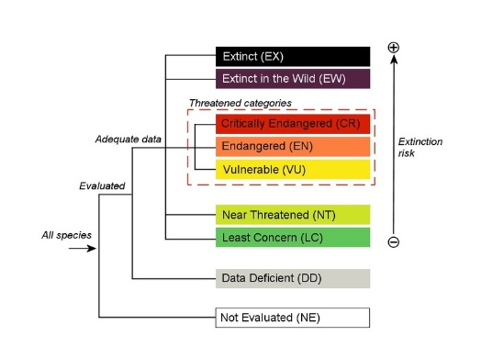

IUCN Green List Of Protected Areas
It documents sites that have made good strides in conservation efforts
(India has no sites under Green list currently )

IUCN Red List Of Ecosystems
It is a tool to assess the conservation status of ecosystems.
