ENVIRONMENT
GEOTHERMAL ENERGY

WHY IN NEWS?
India’s 1st geothermal energy project to be undertaken in Puga valley by ONGC.

BACKGROUND
Geothermal energy refers to energy obtained from the heat trapped within the earth’s surface.
It is available in the form of hotsprings spread and steam trapped in rocks which can be used to run a turbine and generate electricity.

INDIA AND GEOTHERMAL ENERGY
According to the GSI India has an estimated geothermal energy potential of 10GW.
It has identified 7 major provinces in the country from where the geothermal energy can be tapped.
- Himalayan (Puga, Chhumathang),
- Sahara valley(Delhi ridge)
- Cambay basin,
- Son-Narmada-Tapi (SONATA) lineament belt,
- West Coast,
- Godavari basin and
- Mahanadi basin
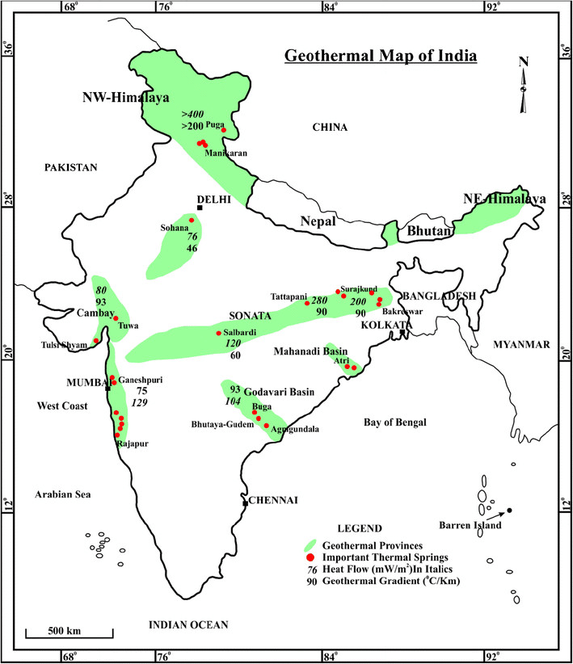
ADVANTAGES
- Available year round
- Clean source of energy
- Minerals obtained from these springs like silica etc can be used for other production and commercial uses
- Ensures energy availability in hilly regions

DISADVANTAGES
- May lead to instability in fragile tectonic zones
- Limited range: Only available in certain areas
- May lead to harmful leaching of chemicals.

